NAME: ELMAD GILA
REG NO: SCCI/03058P/2016
CLASS: B. TECH COMPUTER TECHNOLOGY

UNIT: IBL2 3303 NETWORK DESIGN AND IMPLEMENTATION Class work
1. Using diagrams, describe how a LAN Switch can be used to connect four (4) 40 Marks

Computers, enabling them to send messages amongst themselves.
In your description indicate

- What should be enabled/disabled in the computers

- The Addresses to use in the individual computers

- Suggest possible messaging software to use

Answer
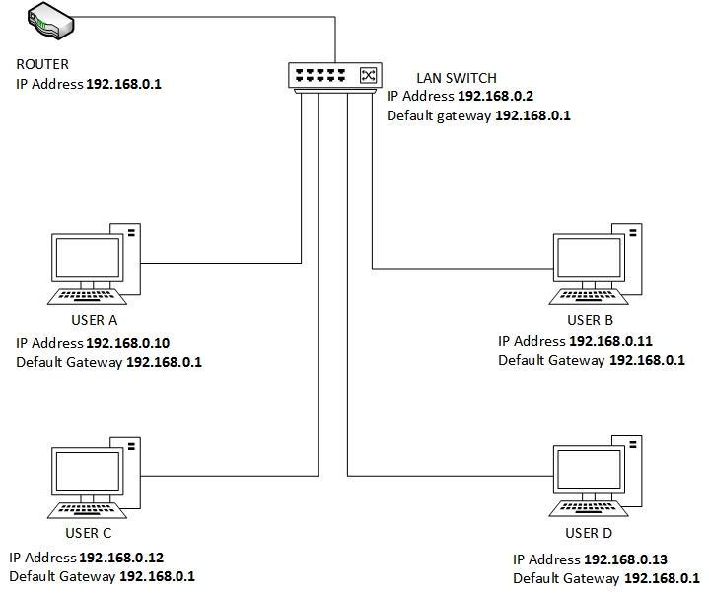

LAN SETUP DESCRIPTION
The following is the steps to be followed up in setting up the above network;

SWITCH CONFIGURATION

- Using a console cable, connect pc to the switch in order to access its terminal for configuration.

Step 1:

Disable DHCP on the switch, this will prevent any remote login to the network. This is accomplished through the following terminal on the switch;

Management > Access > DHCP/Boot config. Under DHCP/Boot Config, disable the DHCP.

Step 2:

Set Ip address and Subnet mask for the switch. The ip address should be static. This is achieved as follows; Management > Access > IP Config

IP Address:192.168.0.2
Default Gateway:192.168.0.1
Subnet mask: 255.255.255.0

Step 3:
Disable SNTP, Spanning Tree and Flow Control
This is to be achieved as follows;
- SNTP: Management > SNTP > Global Configuration
- Spanning Tree: Switch > Spanning Tree > Switch Config/Status
- Flow Control: Traffic Management > Traffic Control > Broadcast Storm/Flow Control.

Step 4:
Configure Ports

Here every switch port is configured with a given ip address for its host.This is achieved as follows

Switch > Port >Config

The following will be the specific ip for its 4 hosts

Port 10(User A) |  | Port 10(User B)
IP Address :192.168.0.10 |  | IP Address :192.168.0.11
Default Gateway:192.168.0.1 |  | Default Gateway:192.168.0.1
Subnet mask:255:255:255:0 |  | Subnet mask:255:255:255:0

Port 10(User C) |  | Port 10(User D)
IP Address :192.168.0.12 |  | IP Address :192.168.0.13
Default Gateway:192.168.0.1 |  | Default Gateway:192.168.0.1
Subnet mask:255:255:255:0 |  | Subnet mask:255:255:255:0

Step 5:
Save the configuration and Restart the system
This is achieved as follows
- Saving Config: Management > Utilities > Save Config
- Restart the system: Management > Utility > System Restart

PC CONFIGURATION

On the hosts Pcs, that is, User A, B, C & D, connect them to the switch using an internet cable then perform the following configuration on each of the four hosts

- Log on to the client computer as Administrator or as Owner.
- Click Start, and then click Control Panel.
- Click Network and Sharing Center
- Click Change Adaptor Settings
- Double click on the current connection to the pc.

- On the list shown on popup dialog box (Ethernet properties), double click on Internet Protocol

Version 4(TCP/IP v4)

- On the popup Internet Protocol Version 4(TCP/IP v4) properties, select General tab, Click Use the following IP address. Here assign various host their respective IPs as follows

Port 10(User A) |  | Port 10(User B)
IP Address :192.168.0.10 |  | IP Address :192.168.0.11
Subnet mask: 255:255:255:0 |  | Subnet mask: 255:255:255:0
Default Gateway:192.168.0.1 |  | Default Gateway:192.168.0.1

Port 10(User C) |  | Port 10(User D)
IP Address :192.168.0.12 |  | IP Address :192.168.0.13
Subnet mask: 255:255:255:0 |  | Subnet mask: 255:255:255:0
Default Gateway:192.168.0.1 |  | Default Gateway:192.168.0.1

- Once done, click on Validate setting upon exit and then click OK
- Quit Control Panel.
MESSAGING SOFTWARE TO BE USED

The four host can use Tonic software for messaging over the network.

Tonic helps one carry out simple chats via LAN network. It is very useful program with a user-friendly interface that is easy to understood by all.

The program operates in peer-to-peer mode, and hence does not need any server. That’s why also it is very easy to operate. It has the following features;

- Easy to use – no server.

- Tonic automatically finds other Tonic users inside your network.

- Different user availability status.

- Image avatars

- File transfer support

- Chat history

- Announcement mode

- Quick poll + poll results.

